Civic And Discussion Forum
Anshul Bhilare¹, Aditya Khandagale², Akash Autade³, Vedant Sasane⁴
Computer Science and Engineering, School of Computing, MIT Art Design and Technology University, Pune, Maharashtra, 412201, India.

Abstract — Urban areas frequently face civic issues such as damaged roads, poor waste management, malfunctioning streetlights, and lack of transparent communication between citizens and government authorities. Traditional complaint systems are slow, fragmented, and lack proper visibility of complaint status.
The Civic and Discussion Forum is a web-based platform that allows citizens to report civic issues with photos, geolocation tagging, and category labels such as roads, sanitation, buildings, and infrastructure. The system also provides local news, announcements, and community discussions where users can share ideas and solutions.
The platform includes features such as upvoting complaints, participating in polls, and discussion threads, allowing citizens to highlight important issues. A government dashboard collects all complaint data and displays analytics such as issue location, resolution progress, and citizen engagement metrics.
By integrating complaint management, community discussions, and government monitoring tools in a single system, the platform improves transparency, faster problem resolution, and civic engagement.
Index Terms— Citizen participation, civic issue reporting, community discussion platform, smart governance, urban problem management.
I. INTRODUCTION
Rapid urbanization has increased the number of civic issues faced by citizens in cities such as poor road conditions, garbage mismanagement, malfunctioning streetlights, water leakage, and unsafe buildings. Citizens often use social media platforms or informal communication channels to report these issues, but such platforms are not designed for structured civic communication. As a result, complaints are scattered, lack verification, and often fail to reach the appropriate government authorities.
Traditional government complaint systems are often slow, complex, and lack transparency, leaving citizens uncertain about the status of their reported problems. Furthermore, citizens rarely receive timely updates about issue resolution, which reduces public trust in governance systems.
To address these challenges, the Civic and Discussion Forum platform is proposed as a web-based system that allows citizens to report civic issues, participate in discussions, and access local announcements in a centralized environment. The platform integrates features such as geotagged complaint submission, image uploads, community discussions, and a government dashboard for monitoring and resolving issues. By combining digital complaint management with community engagement, the system aims to improve transparency, efficiency, and citizen participation in urban governance.

II. CIVIC ISSUE REPORTING AND COMMUNITY DISCUSSION
The Civic and Discussion Forum system integrates multiple digital components to facilitate effective communication between citizens and authorities. The platform enables users to submit civic complaints along with photos, location details, and category labels such as roads, sanitation, electricity, or public safety.
A discussion forum module allows citizens to share their opinions, suggest solutions, and participate in conversations about local issues. This feature promotes collaborative problem-solving and community awareness.
The platform also includes local news updates, announcements, and public polls, allowing citizens to stay informed about civic developments in their area. By combining complaint management with social interaction, the system transforms citizens from passive observers into active participants in governance.
Additionally, the system provides a government dashboard where authorities can analyze complaints, monitor issue trends, and prioritize tasks based on urgency and location.

III. DATA PREPARATION
Data preparation plays an important role in ensuring the effective functioning of the Civic and Discussion Forum platform. The system collects and processes structured information related to civic complaints, user discussions, and community announcements.

A. Data Collection
Data is collected from users who submit complaints, upload images, and participate in discussions. Each complaint includes information such as location, category, description, and timestamp.

B. Data Annotation
Complaints are categorized into predefined civic issue types such as road damage, garbage management, water leakage, streetlight failure, and infrastructure problems.

C. Preprocessing
Uploaded images are resized and optimized for storage and display. Text data from complaints and discussions is cleaned to remove irrelevant characters and ensure readability.

D. Feature Extraction
Important attributes such as location coordinates, issue category, complaint priority, and user engagement metrics are extracted for analysis.

E. Data Splitting and Storage
The data is stored in a structured database where complaint records, user data, and discussion posts are organized in separate tables.

F. Quality and Privacy
User privacy is maintained by protecting personal information and ensuring secure authentication mechanisms.

IV. SYSTEM ARCHITECTURE
The Civic and Discussion Forum system is designed as a modular web-based architecture consisting of several functional components.

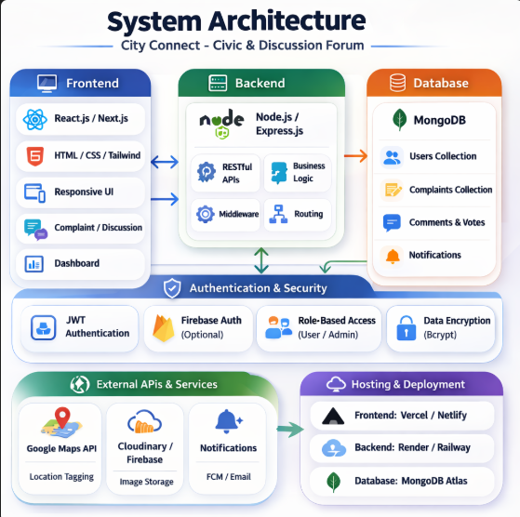
Figure 4.1. System Architecture
The User Interface Module allows citizens to register, log in, submit complaints, and participate in discussions. A Complaint Management Module handles issue submissions, categorization, and tracking.
A Discussion and Announcement Module enables users to share information and interact with other community members.
The Government Dashboard Module provides administrative tools for authorities to monitor complaints, view analytics, and update resolution status.
The system architecture also includes a database layer for storing user data, complaint records, and discussion posts. Web technologies such as HTML, CSS, JavaScript, and backend frameworks support the overall functionality of the platform.

V. RESULTS AND DISCUSSION
The Civic and Discussion Forum system was tested using simulated civic issue reports and user interactions. The system successfully allowed users to register, submit complaints with images and location information, and track the status of their issues.
The discussion forum feature enabled users to participate in conversations about community issues, while the announcement module provided timely updates and notifications.
The government dashboard allowed administrators to analyze complaint trends and prioritize issue resolution based on urgency and location. Testing results indicated that the system improved communication between citizens and authorities while increasing transparency in civic issue management.

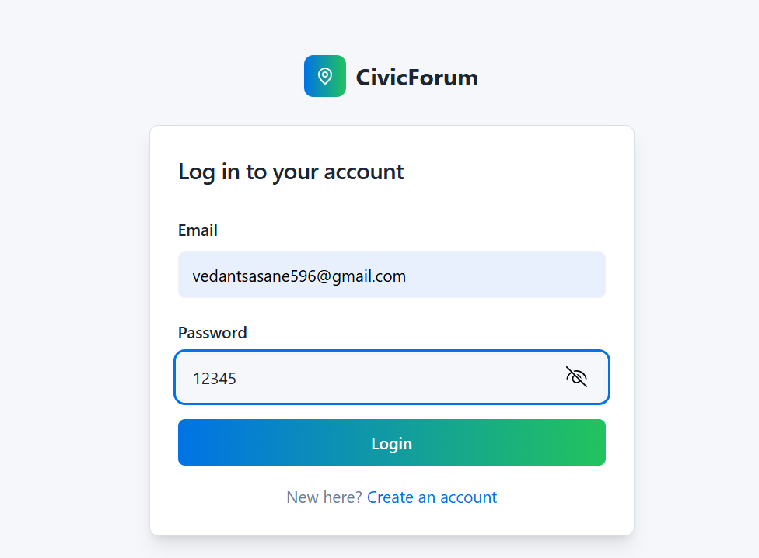
Figure 5.1. Interface

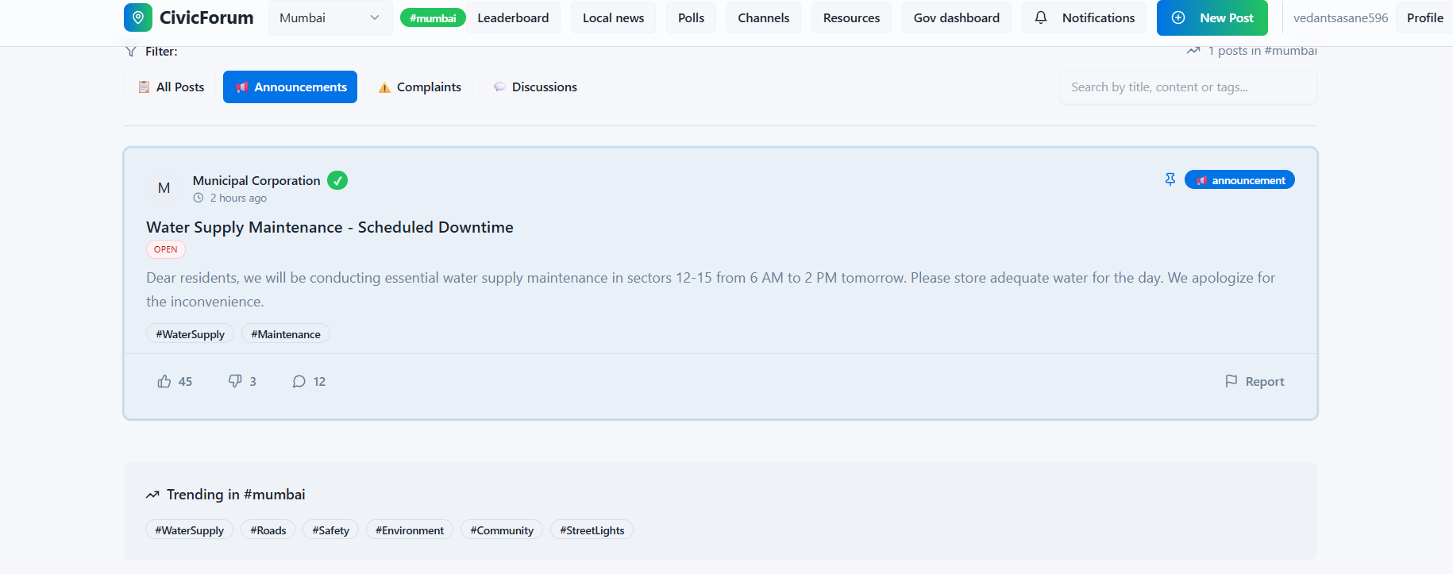
Figure 5.2. List of Announcements
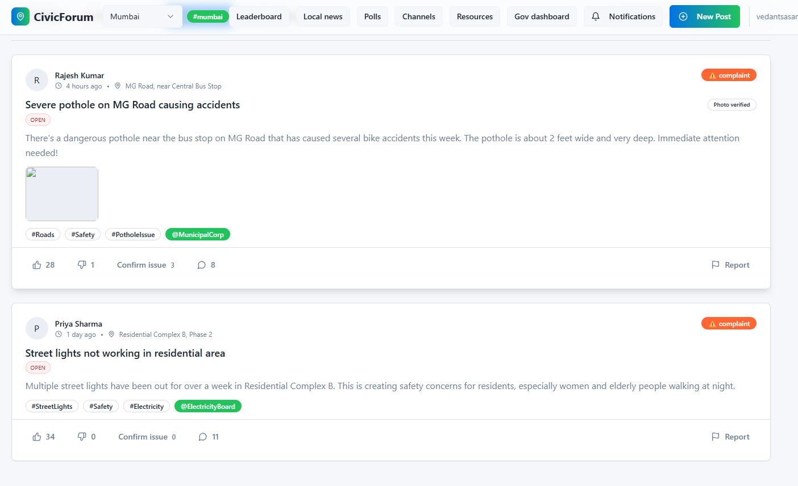
Figure 5.3. List of Complaints

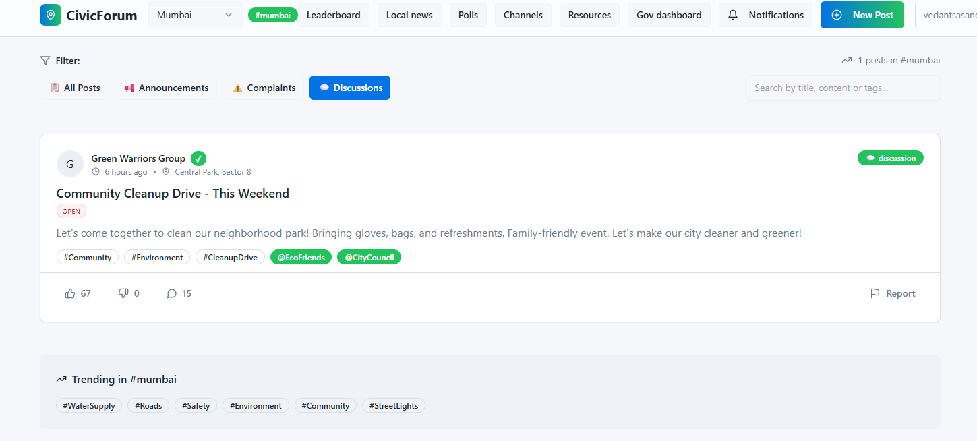
Figure 5.4. Discussion Records

VI. PUBLICATION PRINCIPLES
The contents of the journal are peer-reviewed and archival. The International Journal of Innovative Research in Technology publishes scholarly articles that contribute to the advancement of knowledge in science and technology.
The proposed Civic and Discussion Forum system contributes to the development of smart governance platforms by integrating digital complaint management, community discussion, and civic information sharing into a single web-based system. The research focuses on improving communication between citizens and local authorities through modern web technologies.
The study analyzes existing civic engagement platforms and identifies the limitations of traditional complaint reporting methods. By introducing features such as geotagged complaint submission, community discussion forums, local announcements, and a government dashboard, the proposed system provides a structured and transparent mechanism for handling civic issues.
The design and implementation of the platform demonstrate how digital systems can improve civic participation and transparency in urban governance. The architecture, modules, and implementation details provided in this paper allow other researchers and developers to replicate and extend the proposed system.

VII. CONCLUSION
The Civic and Discussion Forum platform provides a centralized digital solution for managing civic issues and facilitating community engagement. The system enables citizens to report problems, participate in discussions, and stay informed about local developments through announcements and news updates.
The integration of complaint management, discussion forums, and a government monitoring dashboard improves transparency and accountability in civic administration. Authorities can analyze complaint data, identify recurring issues, and prioritize maintenance activities more effectively.

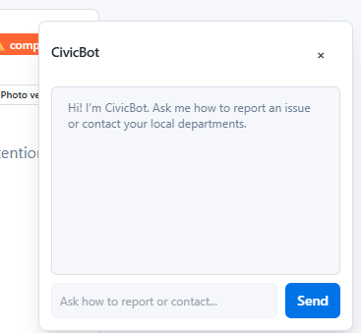
Figure 7.1. Civic Bot for Guide
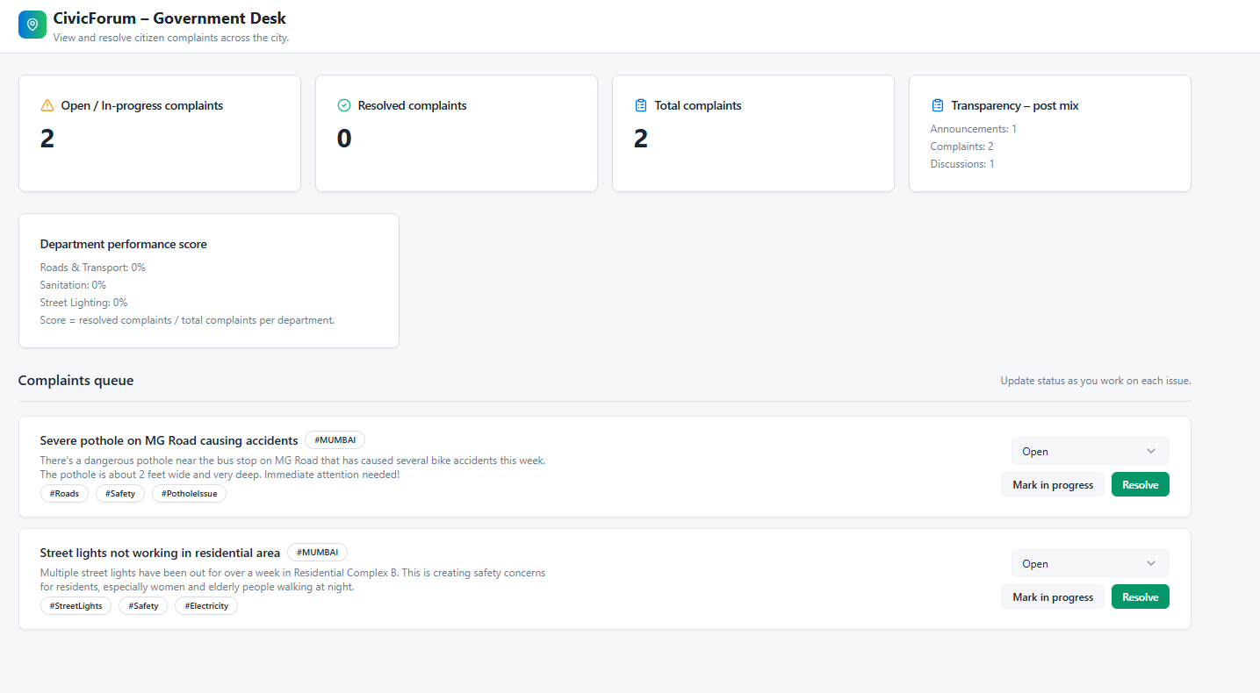
Figure 7.2. Attached Government Dashboard

Future work may include the development of a mobile application, integration with smart city infrastructure, AI-based complaint prioritization, and real-time notification systems. These enhancements can further strengthen the role of digital platforms in improving urban governance and citizen participation.

APPENDIX
The Civic and Discussion Forum platform stores and manages multiple types of data related to users, civic complaints, and discussion posts. The database is structured to maintain organized records and ensure efficient retrieval of information.

A. Complaint Data Structure
Each complaint submitted by a citizen contains the following attributes:
- Complaint ID – Unique identifier for each complaint
- User ID – Identifier of the user who submitted the complaint
- Issue Category – Type of civic issue (road, sanitation, electricity, etc.)
- Description – Detailed explanation of the problem
- Location Coordinates – Geographic location of the issue
- Image Attachment – Optional photo evidence uploaded by the user

ACKNOWLEDGMENT
The authors would like to express their sincere gratitude to Dr. Madhukar Nimbalkar, Faculty Guide, Department of Computer Science and Engineering, MIT School of Engineering, for his valuable guidance, encouragement, and continuous support throughout the development of this project.
The authors also thank the Department of Computer Science and Engineering, MIT School of Engineering, for providing the necessary resources and facilities required to complete this research work successfully.

REFERENCES
[1] S. Gupta and R. Sharma, “Civic Complaint Registration Application for Citizens of Smart Cities,” Journal of Emerging Technologies and Innovative Research, 2024.
[2] M. Singh and A. Verma, “Urban Smart Citizen Engagement Platforms,” Smart Cities Research Whitepaper, 2025.
[3] R. K. Jain, P. Sharma, and A. Verma, “Civic Complaint Application under Smart City Project,” International Journal of Computer Science and Information Technologies, 2016.
[4] Smart City 311 Civic Issue Reporting System. Available: https://www.smartcity311.com
[5] Indore Smart City 311 Application. Available: https://www.smartcityindore.org/311-app/

